Q1) How many records are in the high_peaks_ascents table?
A1) There are 11561 records

Q2) How many records contain a null value for first_ascent_date?
A2) There are 34 records

Q3) How many members climbed the 46 peaks in the winter?
A3) There are 859
SQL3) SELECT count(*) FROM samples.high_peaks_ascents WHERE winter_date is not null;

Q4) What is the least common first_peak?

A4) Emmons

Q5) How many members climbed this peak as their first peak?

A5) only 2

Q6) What is the number of records this inner join would return?
A6) is 11552

Q7) What is the count for the above cartesian product?

A7) The count is 531806

Q8) Does this above query return the same number of records in the result set and the number of records in the high_peaks_ascents table?
A8) Yes, both are 11561

Q9) Paste the SQL you came up with into your worksheet. Remember the column order and column names must match.

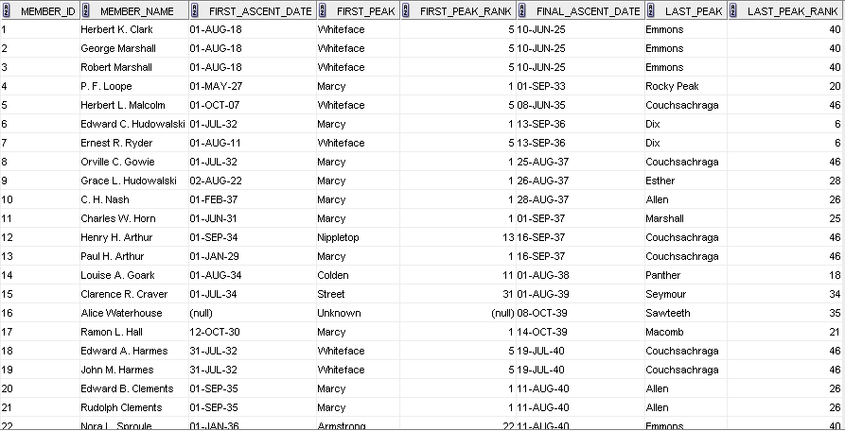

SQL9) [paste SQL here]
SELECT a.member_id, a.member_name, a.first_ascent_date, a.first_peak, hp1.peak_rank first_peak_rank, a.final_ascent_date, a.last_peak, hp2.peak_rank last_peak_rank FROM samples.high_peaks_ascents a, samples.high_peaks hp1, samples.high_peaks hp2 WHERE a.first_peak = hp1.peak_name(+) and a.last_peak = hp2.peak_name(+);

